

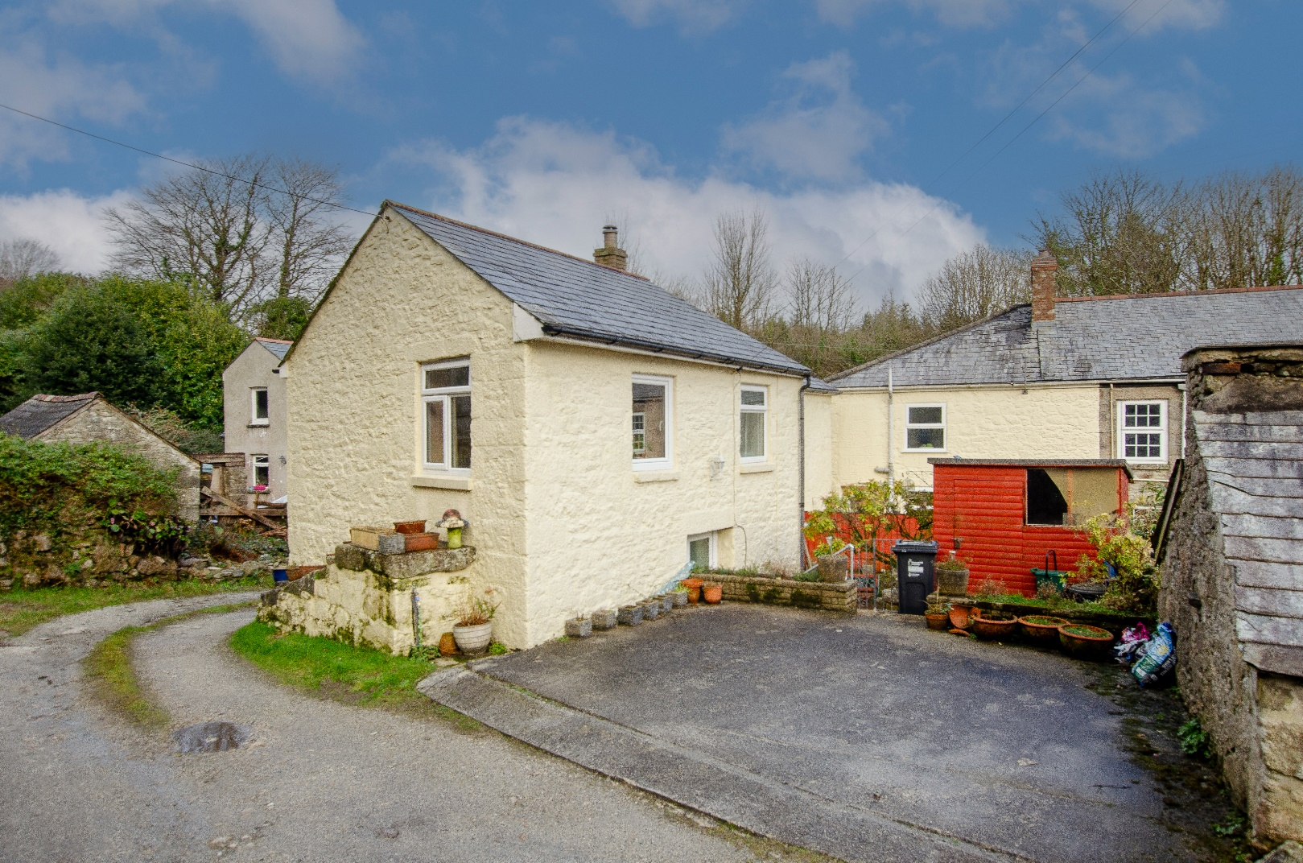

£325,000

,000

|  |  |  |  |
| --- | --- | --- | --- |
|  | |  |  |
|  | |
|  |  |

|  |
| --- |
| An Exciting Opportunity Nestled in the peaceful village of Carthew. This chain free property presents a fantastic opportunity to create a wonderful family home. This three-bedroom detached property offers spacious interiors, generous outdoor space, and endless potential for modernisation. Offering plenty of scope to add value and make your mark, this is a brilliant project for those seeking a spacious home in a desirable location. Don't miss the chance to bring your vision to life—schedule a viewing today! |

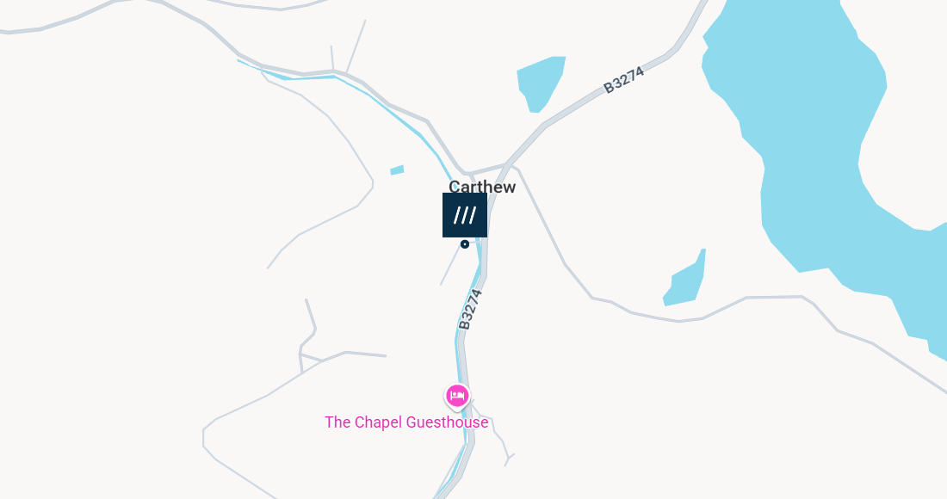

**KEY FEATURES:**

* Three-Bedroom Detached Home
* Chain Free
* Spacious Interiors
* Large Kitchen/Diner
* Private Off-Road Parking For 2 Cars
* Three Well-Proportioned Bedrooms
* Family Bathroom
* Enclosed Rear Garden
* Exciting Project
* Peaceful Village Location

Schools –

Luxulyan School 3.4 miles

Bugle School 5.5 miles

Roche Community Primary School 7.1 miles

Transport links –

There’s a bus stop only a minutes’ walk away from the property and the nearest major train station is St Austell - 7 miles away

The A30 is only a 10-minute drive away which runs from Penzance to Exeter.

**SERVICES**

Heating – Electric  
Water - Mains  
Sewerage – Mains

Local Authority: Cornwall Council

Council Tax band: TBC

What 3 Words ///insect.sheep.honeybees





